**Animal Behavior**

* **Fixed Action Pattern (Niko Tinbergen)**

***A fixed action pattern (FAP) is an innate****, highly stereotypical behavior that, once begun, is continued to completion no matter how useless or silly looking. FAPs are initiated by external stimuli called* ***sign stimuli****.*

*An example of a FAP studied by Tinbergen involves* ***the stickleback fish****, which attacks other males that invade its territory. The releaser for the attack is the red belly of the intruder.*

*Another example is* ***the cuckoo bird****.*

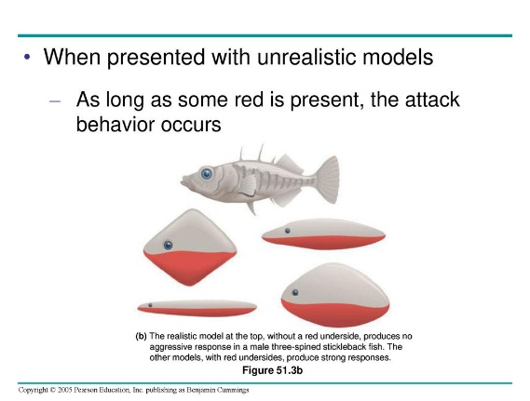

* **Learning**

*Learning is* ***a sophisticated process*** *in which the responses of the organism are modified as* ***a result of experience****.*

*For example, a bird avoids eating a bug after getting sick from it once, or A child touches a hot stove, feels pain, and learns not to touch it again.*

**DR SALMA KHALED BIOLOGY EDUCATOR**

* **Habituation**

***Habituation*** *is when an animal learns to* ***ignore a persistent stimulus****.*

*For example, a hydra at first shrinks when you tap its dish, but after repeated tapping, it stops reacting and continues moving.*

* **Associative Learning**

*1)CLASSICAL CONDITIONING (Ivan Pavlov)*

***Dogs salivate when a bell rings.***

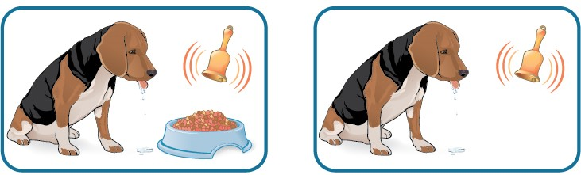

*2)* *OPERANT CONDITIONING (B.F. Skinner)*

***trial and error learning.***

*When an animal learns to* ***associate its behavior with a reward or punishment****.*

*Example: A dog learns to sit when told because it gets* ***a treat*** *each time it does.*

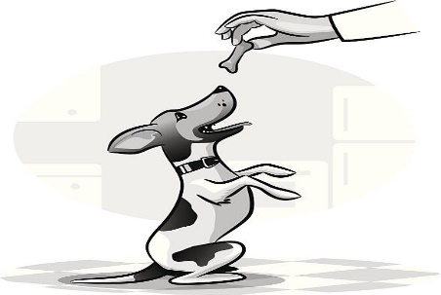

**DR SALMA KHALED BIOLOGY EDUCATOR**

* **Imprinting (Konrad Lorenz)**

*Imprinting is learning that occurs during a sensitive or critical period in the early life of an individual and is irreversible for the length of that period.*

*Geese hatchlings follow the first thing they see.*

* **Social Behavior**

*1) Cooperation*

*Cooperation is when animals work together to do something better, like* ***hunting*** *in a group to catch prey more easily than alone.*

*2)* *Agonistic Behavior*

*Agonistic behavior is* ***aggressive behavior*** *animals use to solve fights over food, mates, or space. It can be real fighting or just showing off.*

*3)* *Dominance Hierarchies*

*Dominance hierarchies are* ***pecking order behaviors*** *where animals show who is the boss. In hens, the top hen (alpha) is at the top of the pecking order and controls the others.*

*4) Territoriality*

*A territory is an area an animal defends to keep others out. It’s used for food, mating, or raising young, and* ***is protected with agonistic (aggressive) behavior****.*

*5)* *Altruism or Kin Selection*

*Altruism is a behavior that reduces an individual’s reproductive fitness, while increasing the fitness of the group or family.* ***When an individual sacrifices itself for the family****, it is sacrificing itself for relatives, which share similar genes. The kin are selected as the recipients of the altruistic behavior.*

**DR SALMA KHALED BIOLOGY EDUCATOR**

**Questions**

***Choose from the list of scientists below.***

*(A) Niko Tinbergen*

*(B) Karl von Frisch*

*(C) B. F. Skinner*

*(D) Konrad Lorenz*

*(E) Ivan Pavlov*

*1. Described the waggle dance in honeybees*

*2. Imprinting*

*3. Trained dogs to salivate at the sound of a bell*

*4. Classical conditioning*

*5. Taught rats in cages to depress a lever to release food*

*6. Baby geese followed him everywhere*

*7. Explained fixed action pattern*

***8)* *A sophisticated process in which the responses of the organism are***

***modified as a result of experience is called***

*(A) fixed action pattern*

*(B) habituation*

*(C) imprinting*

*(D) classical conditioning*

*(E) learning*

***9)* *This behavior reduces an individual’s reproductive fitness while***

***increasing the fitness of the family.***

*(A) Altruism*

*(B) Agonistic behavior*

*(C) Territoriality*

*(D) Cooperation*

*(E) Imprinting*

**DR SALMA KHALED BIOLOGY EDUCATOR**

***Choose from the terms below.***

*(A) Fixed action pattern*

*(B) Habituation*

*(C) Classical conditioning*

*(D) Imprinting*

*(E) Operant conditioning*

***10.*** *Innate, highly stereotypical behavior that must continue until it is*

*completed*

***11.*** *Trial and error learning*

***12.*** *Sequence of behaviors that is unchangeable and carried to*

*completion once initiated*

***13.*** *Initially, the amoeba moved away from the strong light; but after a*

*while, it resumed its normal movement pattern*

***14.*** *This is the way dogs are trained*

***15)* *You want to train your puppy to wait at the curb until you tell him to***

***cross the road. Your friend advises you to give your dog a treat every***

***time he does as you ask. Your friend is advising that you train the dog***

***using***

*(A) operant conditioning*

*(B) classical conditioning*

*(C) imprinting*

*(D) fixed action pattern*

*(E) habituation*

***16)* *_______________ is learning that occurs during a sensitive or critical***

***period in early life and is irreversible for the length of the period.***

*(A) Habituation*

*(B) Operant conditioning*

*(C) Trial and error learning*

*(D) Imprinting*

*(E) Classical conditioning*

**DR SALMA KHALED BIOLOGY EDUCATOR**

***17)*** ***“Mary had a little lamb; its fleece was white as snow. And everywhere***

***that Mary went, the lamb was sure to go.” The behavior of the lamb is***

***best described as***

*(A) habituation*

*(B) imprinting*

*(C) operant conditioning*

*(D) classical conditioning*

*(E) fixed action pattern*

***18)* *Fixed action patterns are initiated by external stimuli called***

*(A) fixed action pattern*

*(B) sign stimuli*

*(C) agonistic behavior*

*(D) dominance hierarchies*

*(E) sensitive periods*

***19)* *Animals that help other animals are expected to be***

*(A) stronger than other animals*

*(B) related to the animals they help*

*(C) male*

*(D) female*

*(E) disabled in some way*

***20)* *An animal that sacrifices itself for its relatives is exhibiting***

*(A) operant conditioning*

*(B) kin selection*

*(C) classical conditioning*

*(D) imprinting*

*(E) habituation*

**DR SALMA KHALED BIOLOGY EDUCATOR**